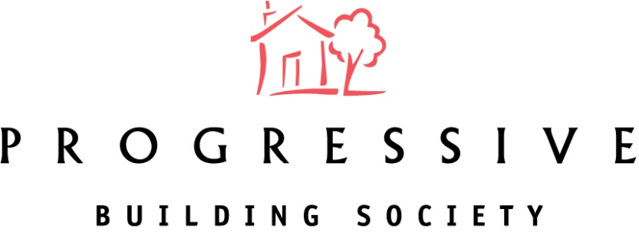

2021 Annual General Meeting Results
The 106th Annual General Meeting (AGM) of your local building society took place on Tuesday 27th April 2021 at Progressive House, 33-37 Wellington Place, Belfast BT1 6HH.
The Society would like to thank all Members who participated in the 2021 AGM vote for the overwhelming support given to the Board's recommendations.
Progressive Building Society pledged to donate 20p for every postal vote and £1 for every online vote cast and this has resulted in a donation of £2,500 to Cancer Focus NI.
The results of the Resolutions proposed at the AGM are shown below:
Ordinary Resolution | For | Against | Withheld | % For
To receive the Directors’ Report, Annual Accounts and Annual Business Statement for the year ended 31st December 2020. | 5752 | 33 | 21 | 99.4%
To approve the re-appointment of Deloitte as Auditors. | 5691 | 79 | 36 | 98.6%
To approve the Report on the Directors’ Remuneration. | 5548 | 201 | 57 | 96.5%
Re-Election of Directors

Margaret Cullen | 5661 | 113 | 32 | 98.0%
Keith Jess | 5667 | 107 | 32 | 98.1%
Declan Moore | 5663 | 111 | 32 | 98.1%
Special Resolution
To consider and, if thought fit, pass a Special Resolution that the Rules of the Society be amended in the manner specified in the document produced to the meeting and initialled by the Chair of the meeting for the purposes of identification. | 5682 | 73 | 51 | 98.7%

